# **PROJECT REPORT**



**REAL-TIME COMMUNICATION**

**SYSTEM POWERED BY AI**

**FOR SPECIALLY ABLED**

Team ID: PNT2022TMID03466

## TEAM MEMBERS:

THENNARASU M [TL] - 212219220055

FAZIL MOHAMED M [TM1] - 212219220008

ROHIT N [TM2] - 212219220043

ANISH GEORGE [TM3] - 212219223001

**ABSTRACT:**

One of the most precious gifts of nature to the human race is the ability to express itself by responding to the events that occur in its environment. Every normal person sees, hears, and then reacts to the situations by expressing himself. But there are some less lucky ones who are deprived of this precious gift. Such people, especially deaf and mute, rely on some sort of gesture language to communicate their feelings to others. The deaf, dumb and the blind follow similar problems when it comes to the use of computers. In the era of advanced technologies, where computers, laptops and other processor-based devices are an integral part of everyday life, efforts must be made to make the disabilities in life more independent. Our goal is to design a human computer interface system that can accurately identify the language of the deaf and dumb. With the use of image processing and artificial intelligence, many techniques and algorithms have been developed in this area. Each character speech recognition system is trained to recognize the characters and convert them into the required pattern. The proposed system aims to give speech speechless, a real-time character language is captured as a series of images, and it is processed and then converted into speech and text.

1. **INTRODUCTION:**

**1.1. Overview:**

In our society, we have people with disabilities. The technology is developing day by day but no significant developments are undertaken for the betterment of these people. Communications between deaf-mute and a normal person has always been a challenging task. It is very difficult for mute people to convey their message to normal people. Since normal people are not trained on hand sign language. In emergency times conveying their message is very difficult. The human hand has remained a popular choice to convey information in situations where other forms like speech cannot be used. Voice Conversion System with Hand Gesture Recognition and translation will be very useful to have a proper conversation between a normal person and an impaired person in any language. The project aims to develop a system that converts the sign language into a human hearing voice in the desired language to convey a message to normal people, as well as convert speech into understandable sign language for the deaf and dumb. We are making use of a convolution neural network to create a model that is trained on different hand gestures. This enables deaf and dumb people to convey their information using signs which get converted to human-understandable language as output.

**1.2. Purpose:**

Dumb people are usually face some problems on normal communication with other people in society. It has been observed that they sometimes find it difficult to interact with normal people with their gestures. Because people with hearing problems or deaf people cannot speak like normal people, they have to depend on a kind of visual communication in most cases. To overcome these problems, we have proposed a system that uses cameras to capture and convert videos of hand gestures from dumb people who turn into speech for understanding normal people. The primary application for addressing the sign language is the improvement of the sign language. Computer recognition of the sign language is an important research problem for communication with the hearing impaired. The system proposed to develop and build an intelligent system that uses image processing, machine learning and artificial intelligence concepts to make visual inputs of hand gestures of sign language and to create an easily recognizable form of outputs.

# 2. LITERATURE SURVEY:

## 2.1. Existing Problem:

1. **Two Way Communicator between Deaf and Dumb People and Normal People. [1]**

This system consists mainly of two modules, the first module is Indian Sign Language (ISL) gestures from real-time video and mapping it with human-Understandable speech. Accordingly, the second module is the natural language as Input and card with equivalent Indian Sign Language animated gestures.

1. **Sign Language Recognition System to aid Deaf-dumb People Using PCA. [2]**

This paper presents design and implementation of real-time sign language recognition system, to 26 gestures from the Indian sign language with MATLAB.

1. **Sign Language to Text and Vice Versa Recognition using Computer Vision in Marathi. [3]**

In this system edge detection algorithm is used to recognize the input character image gray scale and recognition of the edges of the hand gesture. The system is able to handle the different input records images of alphabets, words, sentences, and translates them in text and vice versa. The system is designed to translate the Marathi sign language to text.

**D. Sign Language Learning based on Android for Deaf and Speech Impaired People. [4]**

This research makes an Android-based application that can directly interpret Sign language presented by deaf people in written language. Translation process Starts with the detection of hands with OpenCV and translation of and signals The K-NN classification. Tutorial features added in this application with the goal to train intensively to guide the user when using the sign language.

# 2.2. References:

1. Prof. P.G. Ahire, K.B. Tilekary,T.A. Jawake, P.B. Warale,“Two Way Communicator between Deaf and Dumb Peopleand Normal People", 978-1-4799-6892-3/15 31.00 c 2015 IEEE.
2. Shreyashi Narayan Sawant, "Sign Language recognition System to aid Deaf- dumb People Using PCA", IJCSET ISSN : 2229-3345 Vol. 5 No. 05 May 2014.
3. Amitkumar Shinde, Ramesh Kagalkar, ”Sign Language to Text and Vice Versa Recognition using Computer Vision in Marathi”, International Journal of Computer Applications (0975 – 8887) National Conference on Advances in Computing (NCAC 2015)

Setiawardhana, Rizky Yuniar Hakkun, Achmad Baharuddin, "Sign Language Learning based on Android For Deaf and Speech Impaired People", 978-1-4673-9345-4/15/31.00 c 2015 IEEE.

**[5]** W. Sureshkumar and R. Rama, “Chomsky hierarchy control on isotonic array P systems,” International Journal of Pattern Recognition and Artificial Intelligence, vol. 30, no. 2, pp. 1650004–1650249, 2016.

**[6]** L. Zhou, G. Yang, Y. Yin, L. Yang, and K. Wang, “Finger vein recognition based on stable and discriminative superpixels,” International Journal of Pattern Recognition &

Artificial Intelligence, vol. 30, no. 6, pp. 1650015–1650079, 2016.

**[7]** Y. Zhang-Jing, H. Pu, and Z. Fan-Long, “Center-based line neighborhood discriminant embedding algorithm and its application to face recognition,” Pattern Recognition &

Artificial Intelligence, vol. 21, no. 3, p. 65, 2015.

**[8]** D. Verma and S. Dubey, “Fuzzy brain storm optimization and adaptive thresholding for multimodal vein-based recognition system,” International Journal of Pattern Recognition & Artificial Intelligence, vol. 13, no. 5, pp. 49–61, 2016.

**[9]** F. Tian, Y. Gao, Z. Fang, and J. Gu, “Automatic coronary artery segmentation algorithm based on deep learning and digital image processing,” Applied Intelligence, vol. 51, no. 12, pp. 8881–8895, 2021.

**[10]** E. Giacomin, T. Greenberg-Toledo, S. Kvatinsky, and P.E. Gaillardon, “A robust digital RRAM-based convolutional block for low-power image processing and learning

applications,” IEEE Transactions on Circuits and Systems I: Regular Papers, vol. 66, no. 2, pp. 643–654, 2019.

**[11]** Z. Che and X. Zhuang, “Digital affine shear filter banks with 2layer structure and their applications in image processing,” IEEE Transactions on Image Processing, vol. 27, no. 8, pp. 3931–3941, 2018.

**[12]** L. Zhang, L. Zhang, and L. Zhang, “Application research of digital media image processing technology based on wavelet transform,” EURASIP Journal on Image and Video Processing, vol. 2018, no. 1, 2018.

**[13]** R. Mouhcine, A. Mustapha, and M. Zouhir, “Recognition of cursive Arabic handwritten text using embedded training based on HMMs,” Journal of Electrical Systems & Information Technology, vol. 32, no. 1, p. 455, 2017.

## 2.3. Proposed solution:

This paper describes the system that overcomes the problem faced by the speech and hearing impaired. The objectives of the research are as follow:

1. To design and develop a system which lowers the communication gap between speech hearing impaired and normal world.

2. To build a communication system that enables communications between deaf-dumb person and a normal person.

3. A convolution neural network is being used to develop a model that is trained on various hand movements. This model is used to create an app. This programme allows deaf and hard of hearing persons to communicate using signs that are then translated into human readable text.

# 3. IDEATION & PROPOSED SYSTEM

**3.1. Empathy Map Canvas:**

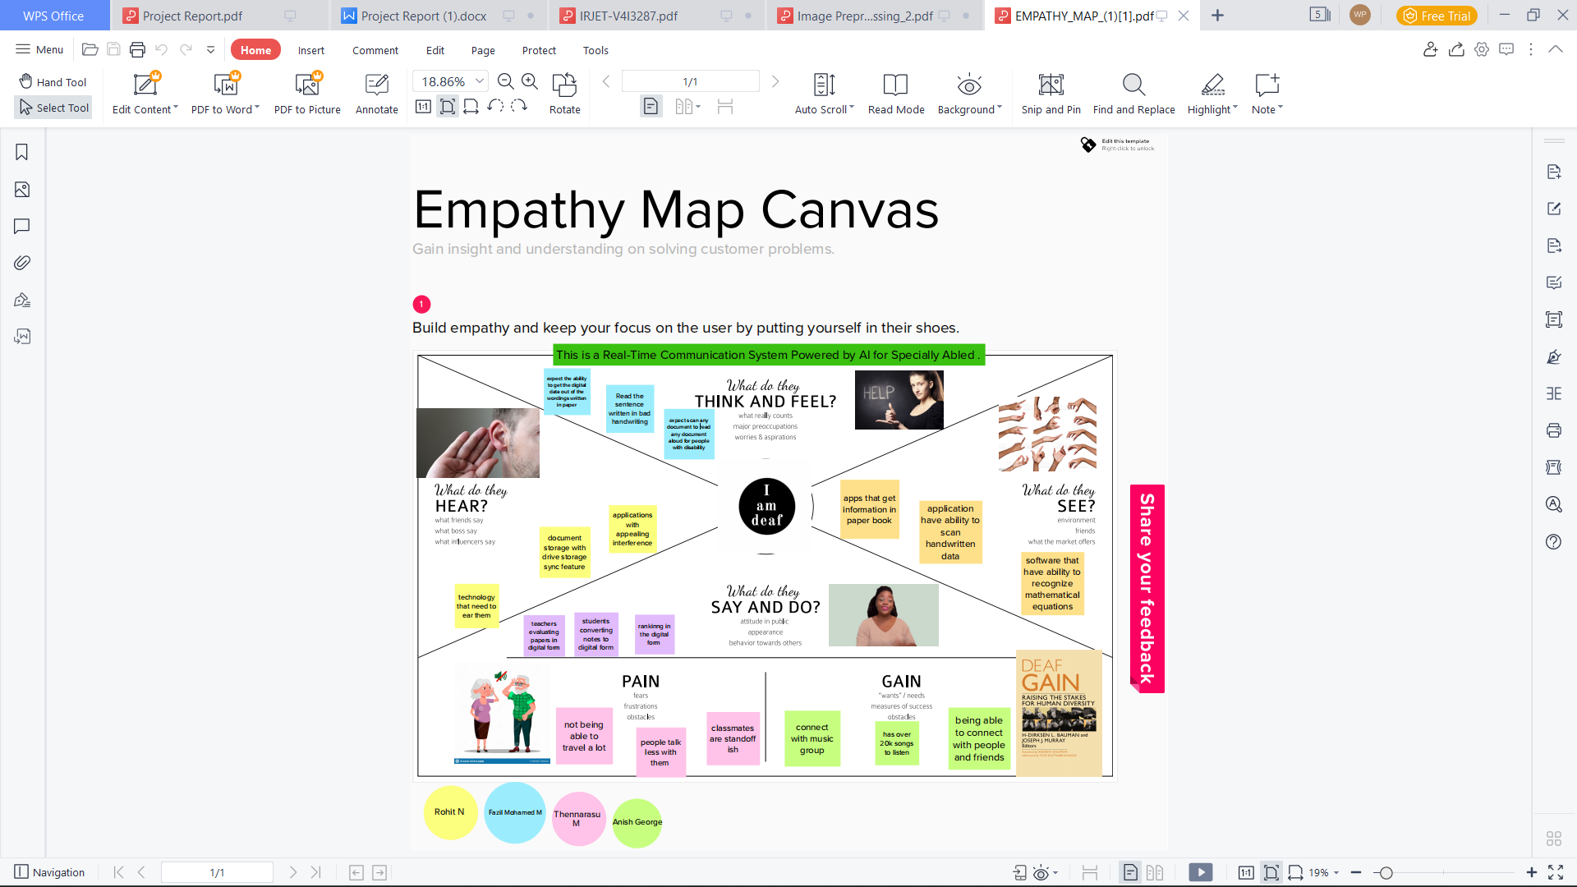

# 3.2. Ideation & Brainstorm:

# 

# 3.3. Proposed Solution:

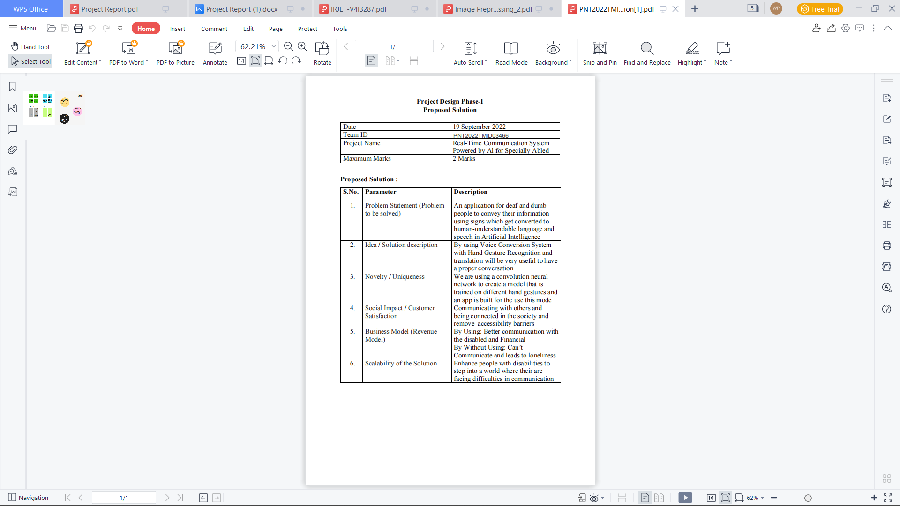

# 3.4. Problem Solution Fit:

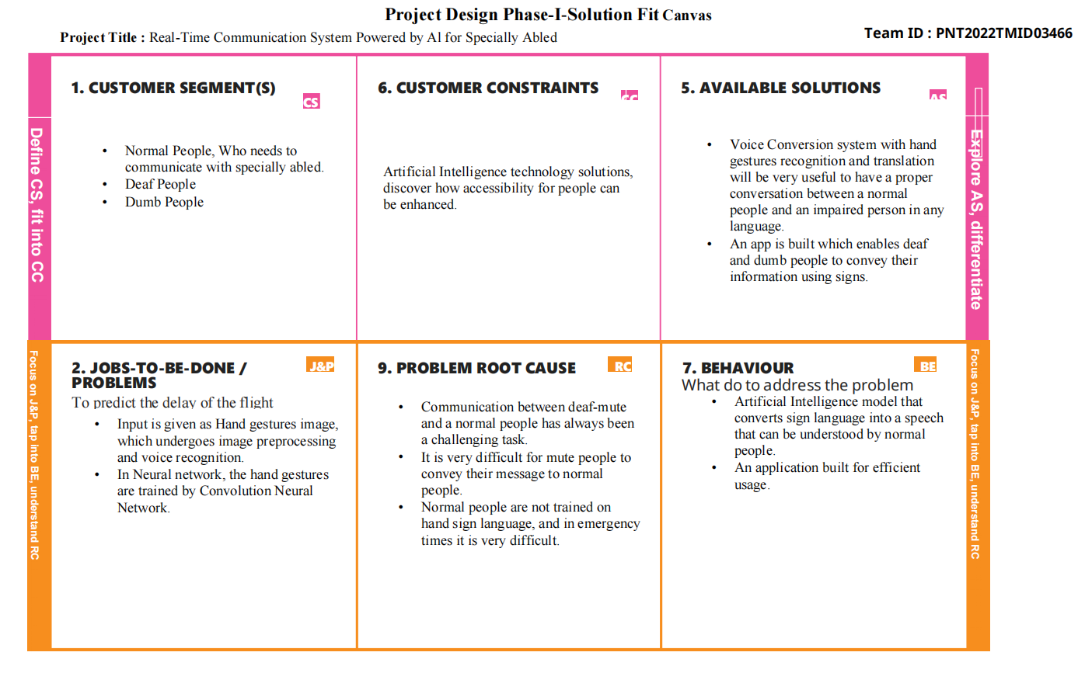

# 

# **Requirement Analysis**

# Functional Requirement:

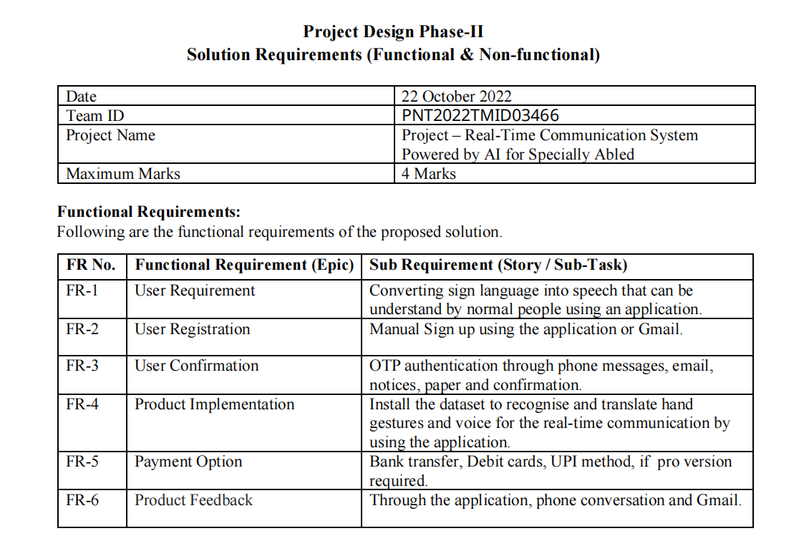

# Non-Functional Requirement:

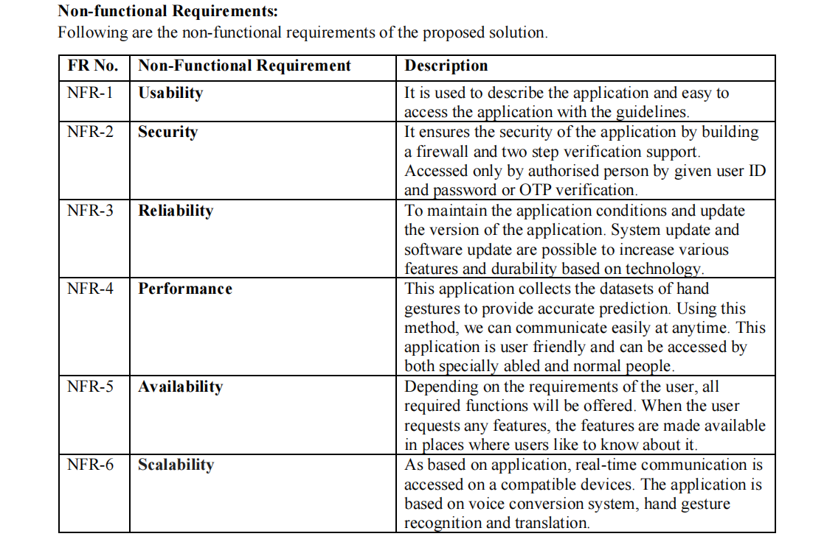

## PROJECT DESIGN:

# Data Flow Diagram:

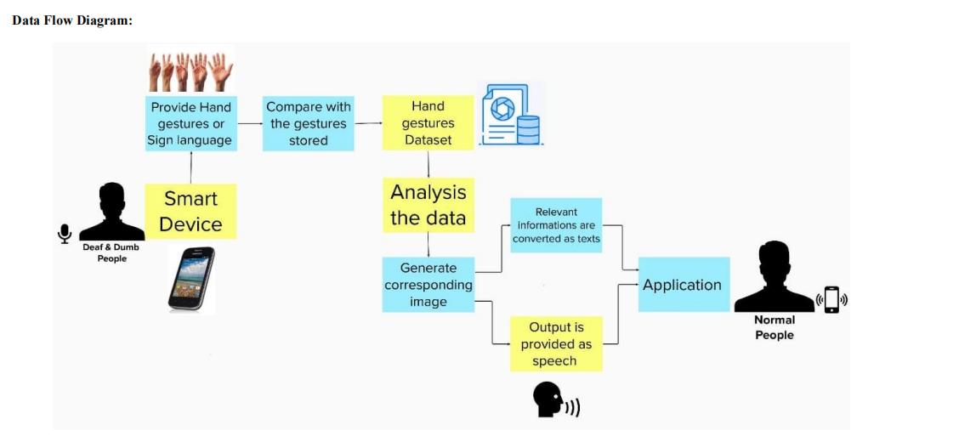

# Solution & Technical Architecture:

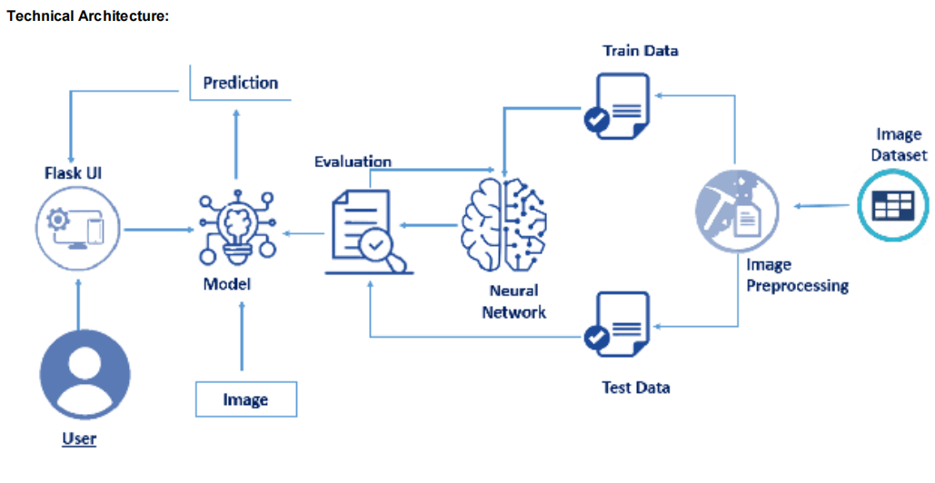

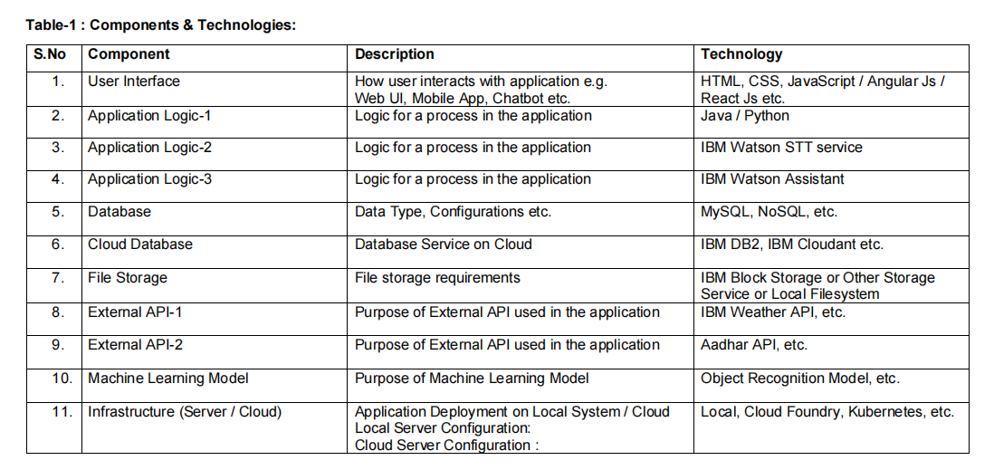

# 5.3. User Stories:

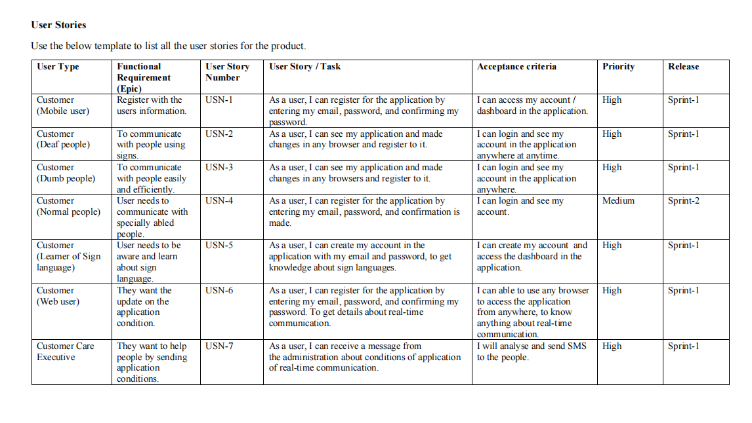

# CODING & SOLUTIONING

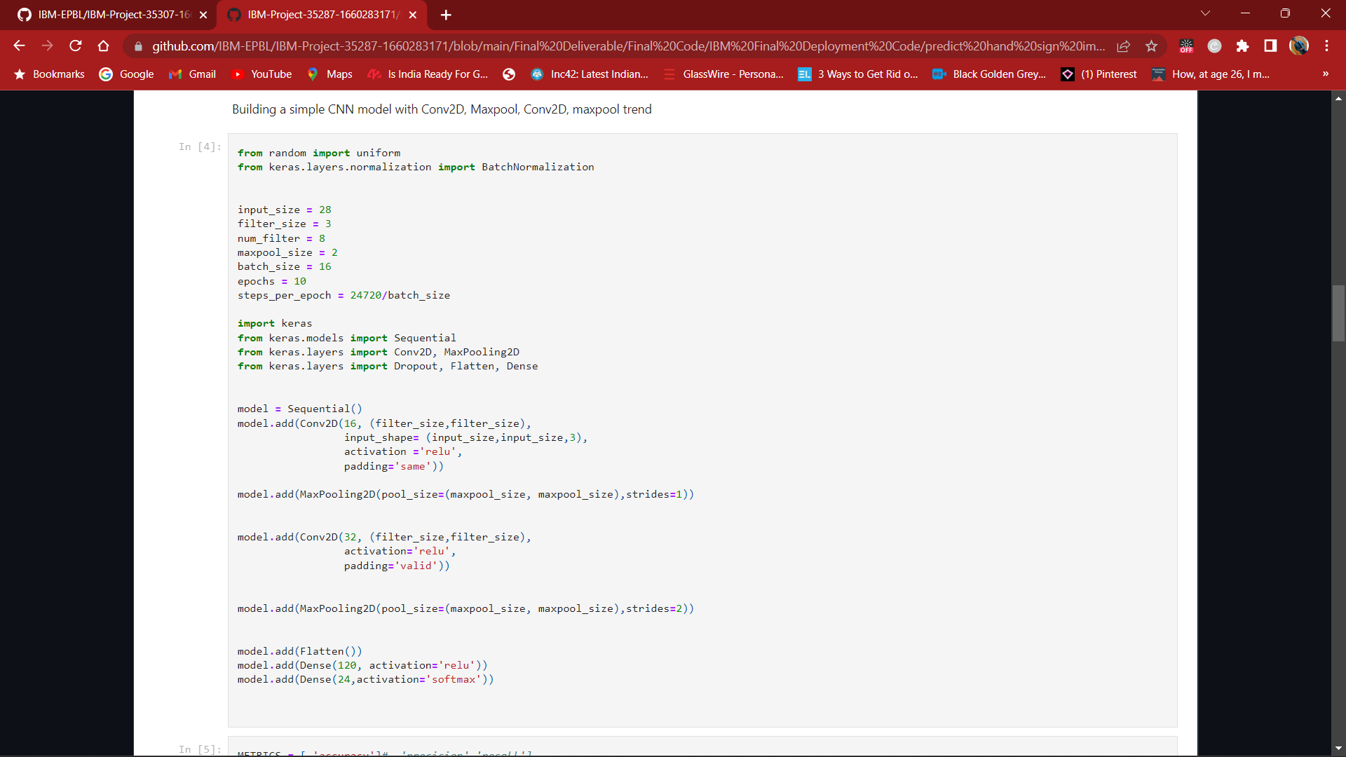

# Screenshot (37)

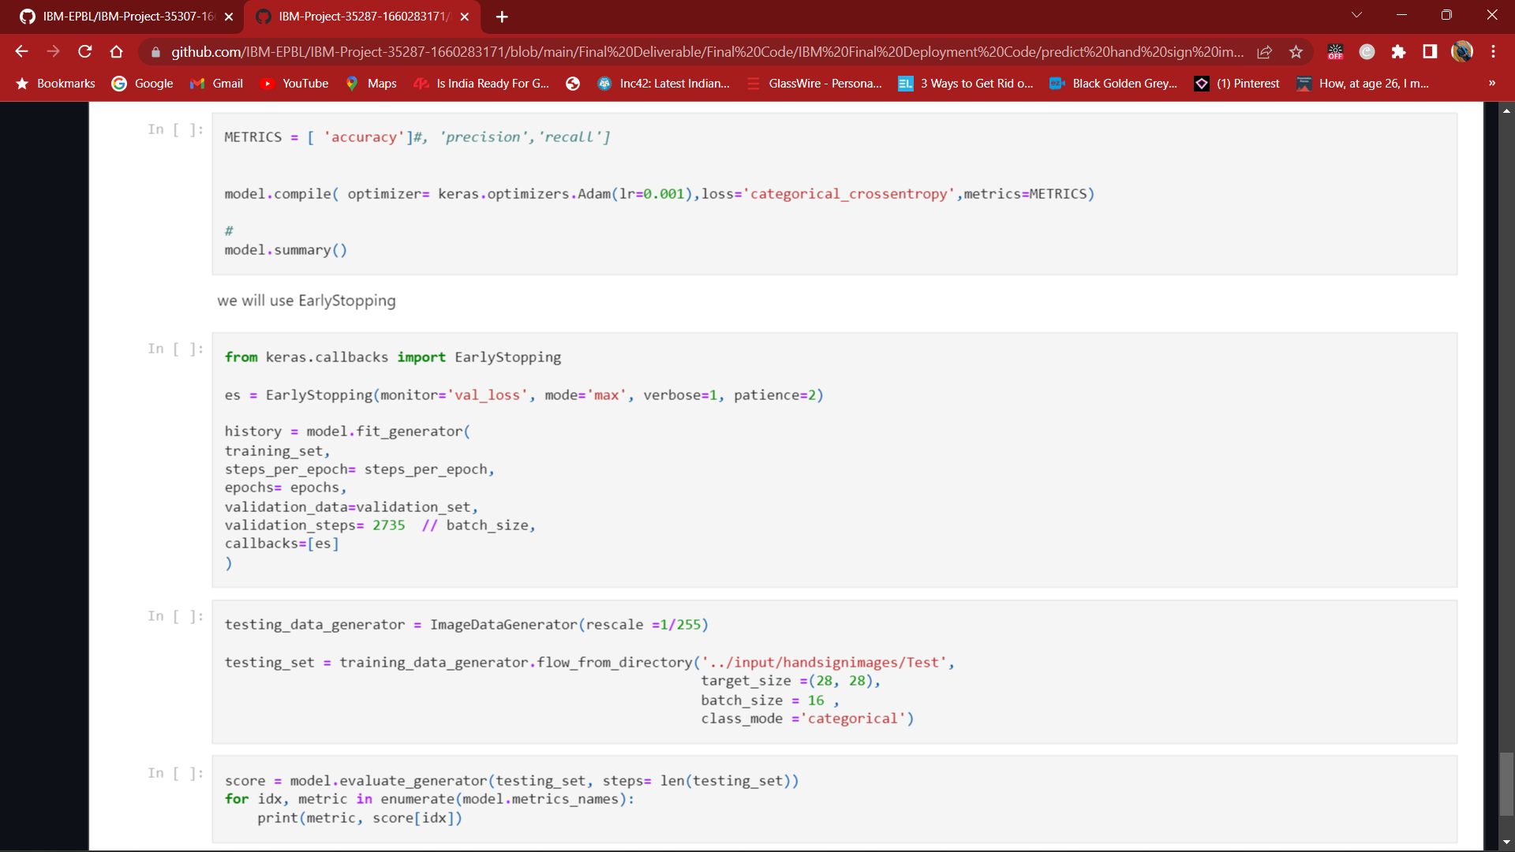

# **Model Building:**

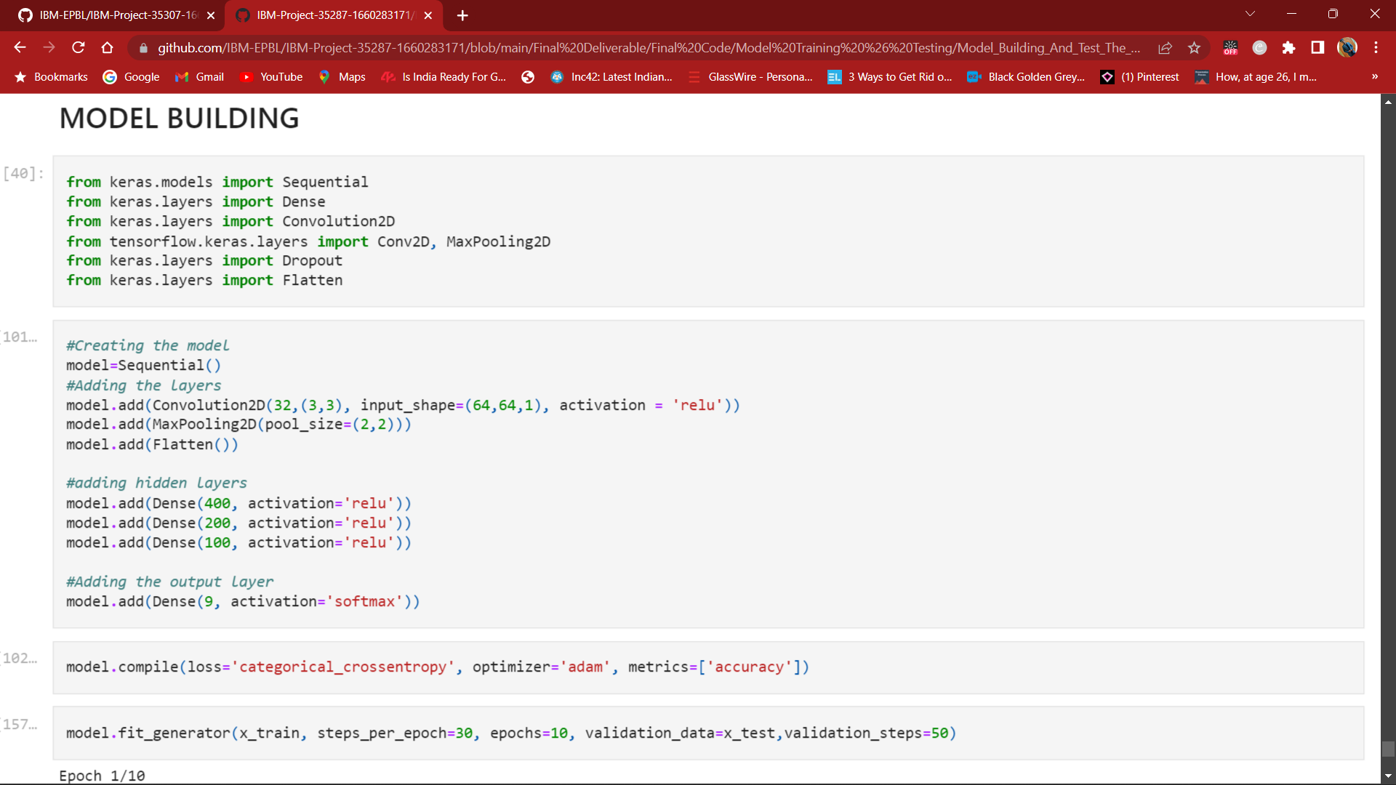

# **WhatsApp Image 2022-11-17 at 18.40.20**

# **Data Scheme:**

# Screenshot (35)

# Screenshot (40)

# Screenshot (41)

# TESTING

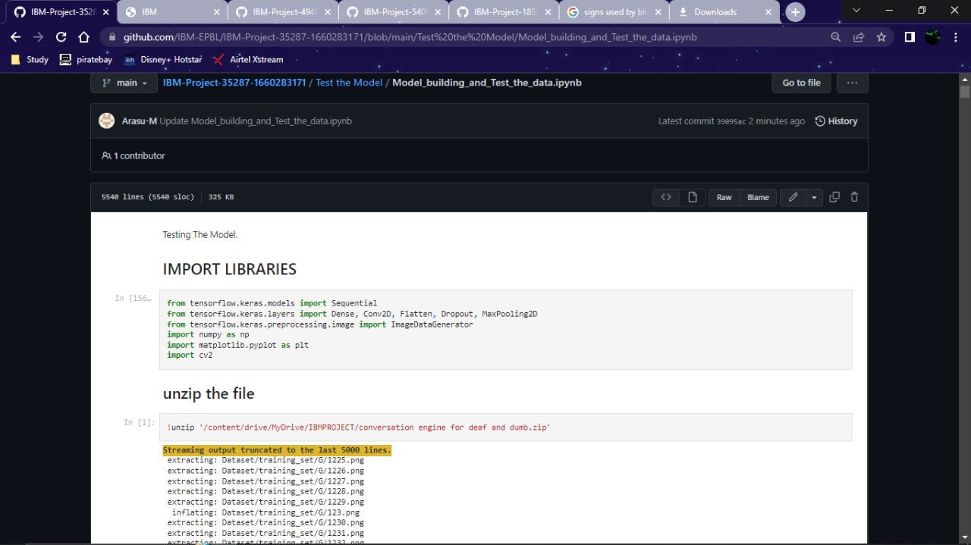

# WhatsApp Image 2022-11-17 at 18.42.27

# TEST THE MODEL

# Screenshot (44)

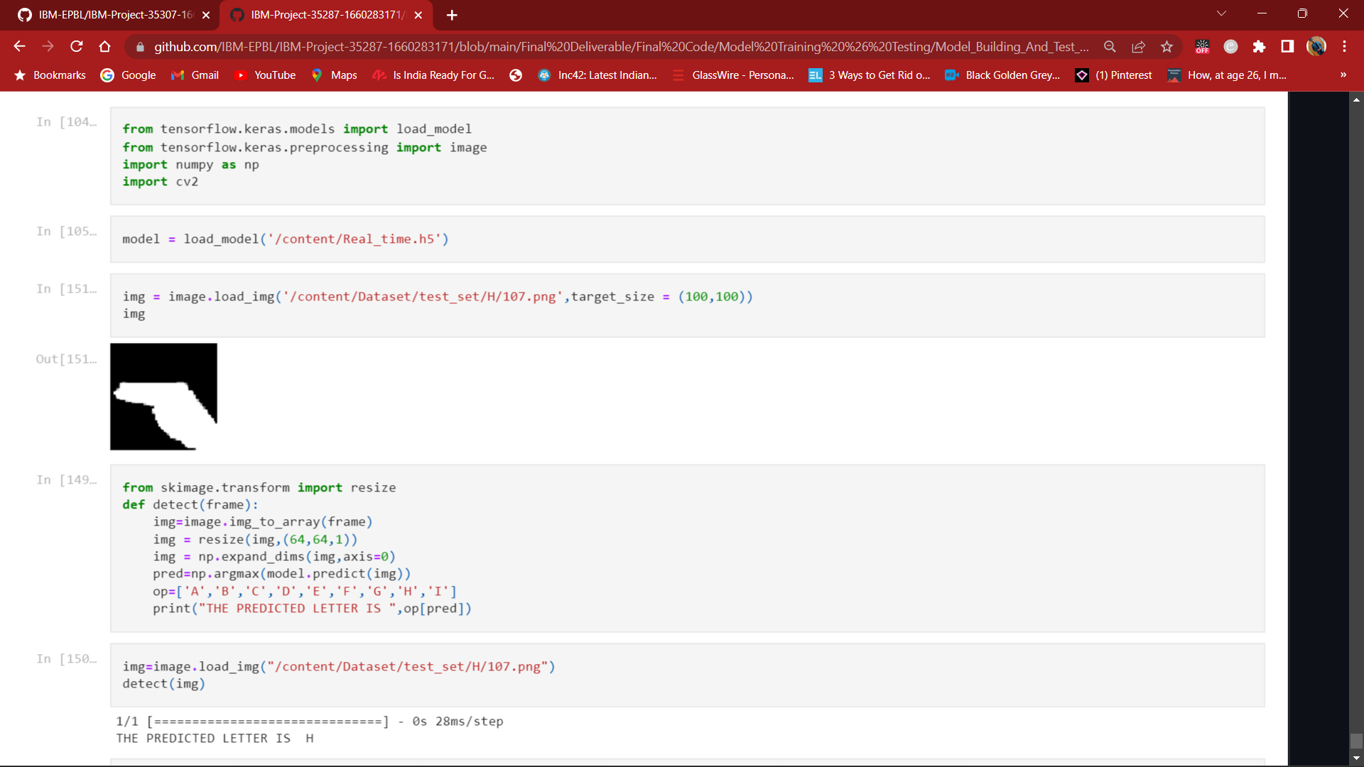

# RESULT

# Output Screenshot:

Our model recognize the following sign languages:

**I LOVE YOU**

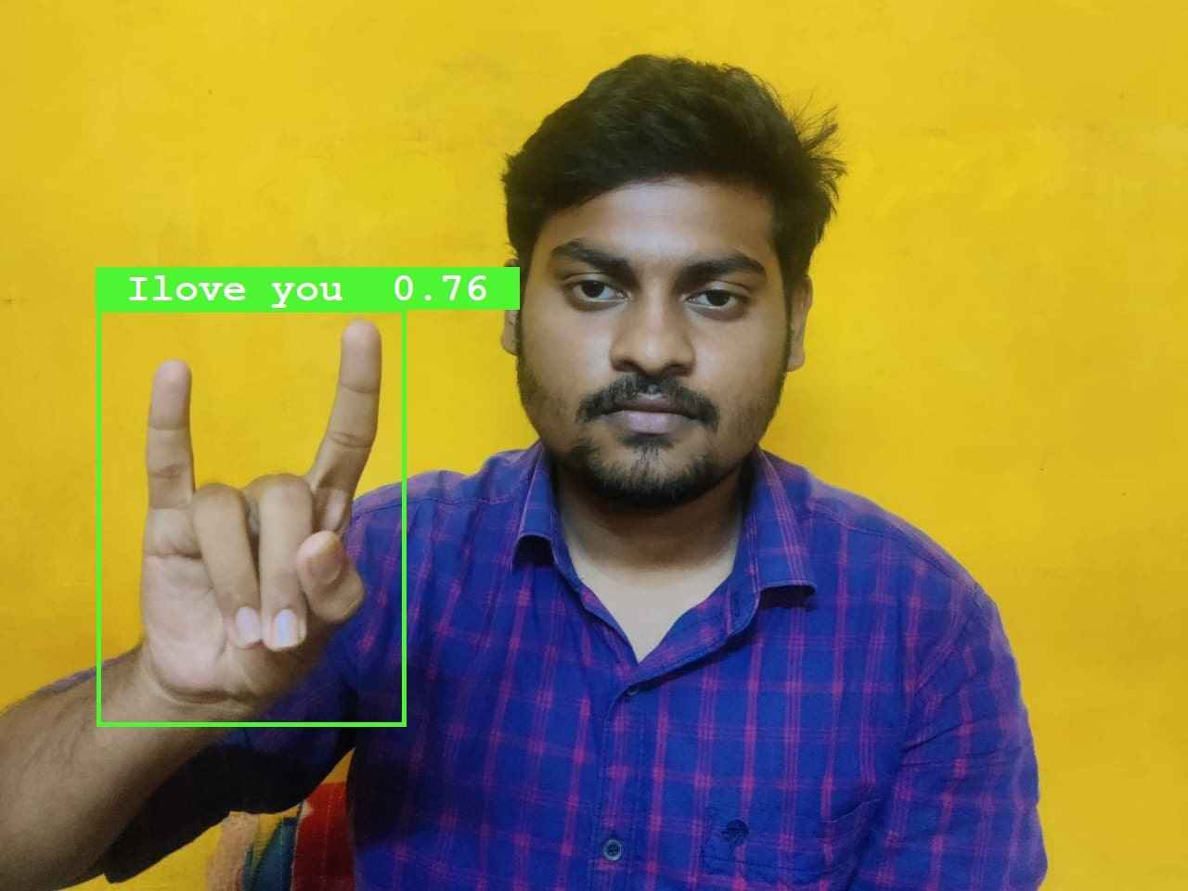

**hELLO**

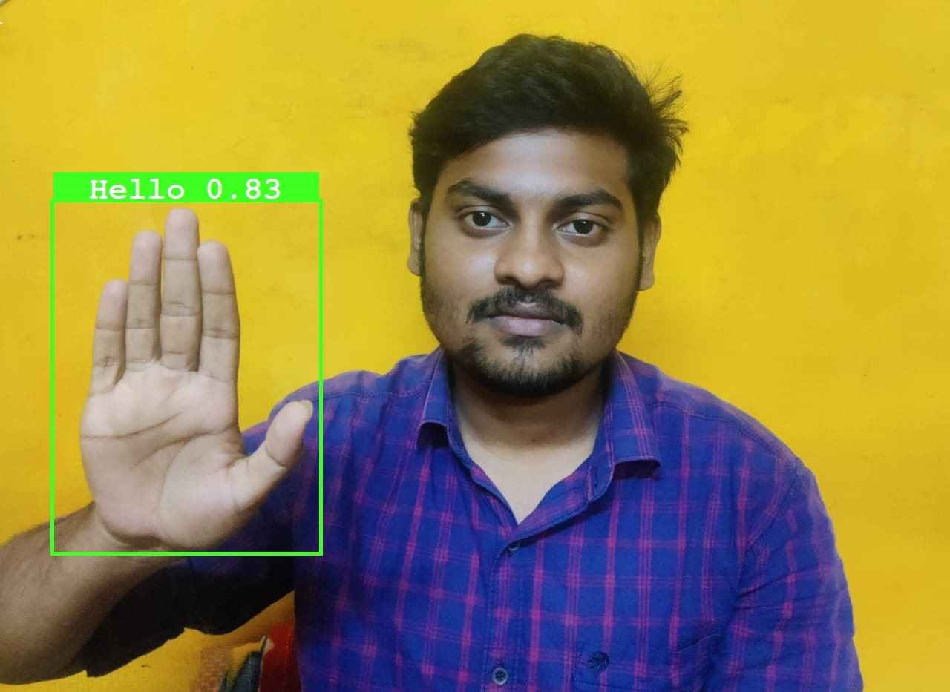

**NO**

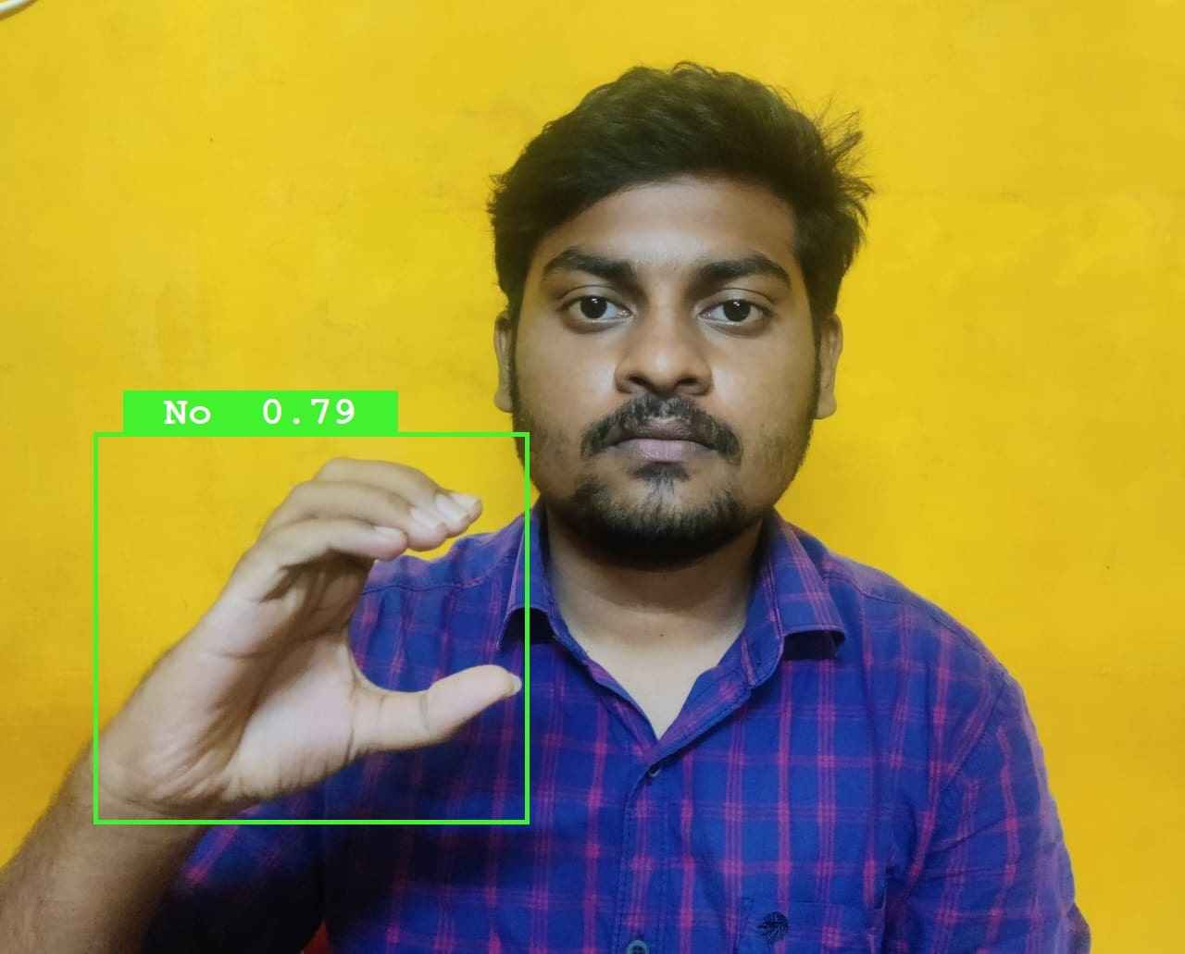

**Thank you**

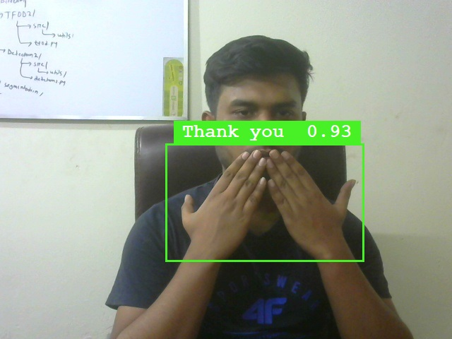

**yES**

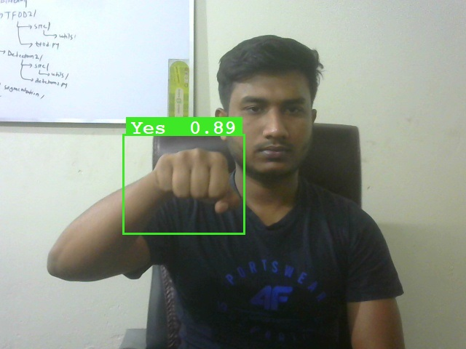

# ADVANTAGES & DISADVANTAGES:

**Advantage:**

[1] Integrate the deaf and mute community into the conventional world..

[2] Smoothen the day-to-day interaction of deaf and mute people.

[3] Recognize the diverse range of sign languages present around the globe.

[4] Provide a feasible platform for the conventional world to interact with the deaf and mute community.

[5] Eliminate discrimination because of the perceptable communication gap.

**Disadvantage:**

[1] High Cost.

[2] Accuracy may vary.

[3] Highly depend on the composition of the images.

[4] As the quantity/quality of images in the dataset is low, the accuracy is not great, but that can easily be improved by change in dataset.

# CONCLUSION

The proposed communication system between Deaf and Dumb people and ordinary people are aiming for it when bridging the communication gap between two societies. Several work is done earlier in this area, but this paper adds in complete two - sided communication in an efficient manner because the system is implemented as one Handy mobile application. So, it really serves its needs in all aspects. The above strategies prove to be efficient In terms of time and accuracy. Further improvements can be done in the implementation of the communicator with other sign language such as American Sign Language, Accent recognition for different accents throughout Globe, recognition of emotions in sign language and language Translation.

# FUTURE SCOPE:

* Proposed systems scope is related with education of dumb peoples. Dumb people faces many problems when normal person could not understand their language. They were facing communication gap with normal peoples.
* For communication between deaf person and a second person, a mediator is required to translate sign language of deaf person. But a mediator is required to know the sign language used by deaf person. But this is not always possible since there are multiple sign languages for multiple languages. So to understand all sign languages, Hand gestures of deaf peoples by normal peoples this system is proposed. System gives output in the form of sound.

# Upgrade datasets and training to recognize combination of static gestures.

# Interpretation of facial expression by the real-time system.

# Inclusion of different types of sign languages.

# Integrating more words into the vocabulary of the system.

# APPENDIX

